

ECTE477
Project Report

Project Overview
For this project, we used the TurtleBot3 Burger robot running on ROS 2. To control the robot, we connected to it using the command ssh ubuntu@192.168.15.182 [1]. We also checked the settings using nano ~/.bashrc to make sure the robot and our computer were on the same ID. Once connected, we ran the standard bringup command on the robot itself to turn on the motors and sensors [2]. You can see how these parts work together in the Functional Diagram:
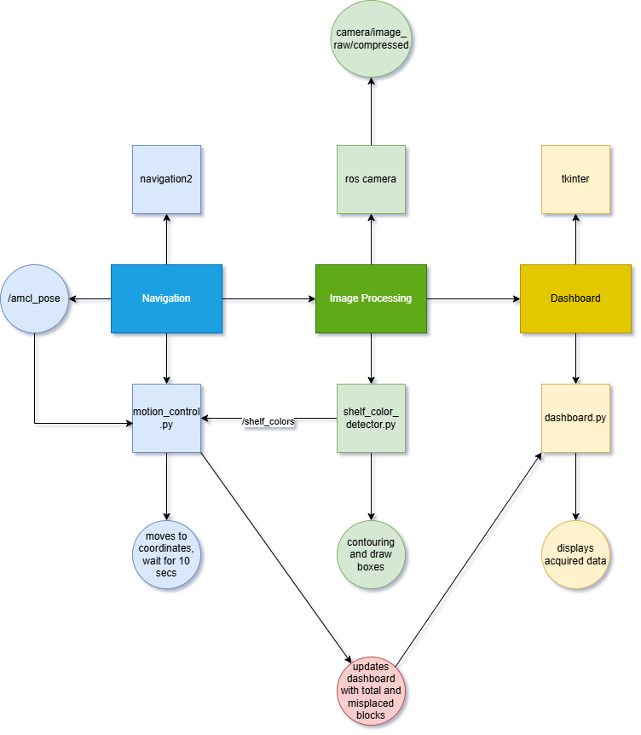

Mapping
In this section, we explored the map and saved the attained map using the following steps:
- Place the bot at the starting position in the maze
- Launch RVIZ [3]
- Launch Cartographer [4]
- Run the Teleop command [5]
- After mapping and confirming the map, save the map to the desired destination using:
ros2 run nav2_map_server map_saver_cli -f /home/ros/turtlebot3_ws/src/aot_pkg/aot_pkg/maps/map2.yaml [6]
- The map can be seen in figure 7 in the appendix.

Navigation
In this section, we had the bot move autonomously, reach three separate points and wait for a while for the image processing. Once complete, the bot returns to the start point. The following steps were used:
- Stop, RVIZ, Cartographer and teleop.
- Run the navigation command:
ros2 launch turtlebot3_navigation2 navigation2.launch.py map:=/home/ros/turtlebot3_ws/src/aot_pkg/aot_pkg/maps/map2.yaml [8]
- This opened RViz.
- To move bot to a point do 2d pose estimate and nav2 goal [9]
- 2d pose estimate was used to define the current orientation (starting point) of the robot on the map.
- Then nav2 goal was used to make the bot move to a specific point on the map and face in a certain direction.
- The AMCL_pose command would print the bot’s real time coordinates (the position and orientation). Minor tweaks were then made depending on the current orientation.
ros2 topic echo /amcl_pose --once [10]
- The coordinates (position and orientation) previously obtained from the amcl_pose topic were hardcoded into the motion_control.py script within the self.shelves list. This created a fixed map with targets.
- Instead of manually setting a "nav2 goal" in RViz for every step, It sends the stored coordinates to the action server, instructing the robot to move to the specific shelf autonomously without hitting any walls.
- The navigation feedback is monitored and once the robot successfully reaches the goal, the bot is made to wait for 10 seconds. [11]
- These 10 seconds allow the robot to stabilize completely. During this time, the ROS node stays active so it can receive data and make sure that the Image Processing node has a stable video feed to detect the blocks before the bot moves to the next location.

Image Processing
In this section, we detected the blocks on each shelf and determined their color to count and detect any misplaced blocks. The following steps were used:
- SSH into bot on another window
- Launch camera node on the bot for publishing using:
ros2 launch camera_ros camera.launch.py [12]
- If first time trying to launch the camera, a command is needed to install:
sudo apt install ros-humble-camera-ros [13]
- Then on the pc itself, to subscribe to the camera/image_raw/compressed topic, the following installation is made:
sudo apt install ros-humble-image-transport-plugins [14]
- rqt command is used to view the camera feed on the compressed topic [15]. Images of each shelf are taken here [16].
- The color ranges for each color were then determined by navigating to the util directory in practice_mazes package and accessing the range detector. These were the steps:
  - Give permission to use by the command:
chmod +x range_detector.py [17]
  - Use the range detector on the desired picture using the command:
./range_detector.py -f HSV -i home/ros/turtlebot3_ws/src/aot_pkg/redyelloworangem1.png -p [17]
- These ranges were made sure not to overlap to avoid any confusion between different colours using the slider. [18]
- The following are the determined ranges:
  - yellow_range = ((26, 73, 190), (35, 255, 255))
  - lime_range = ((43, 79, 0), (50, 145, 255))
  - green_range = ((59, 100, 0), (75, 204, 255))
  - purple_range = ((107, 34, 87), (150, 115, 231))
  - blue_range = ((92, 73, 0), (103, 200, 255))
- Based on these, the colour range values were edited within the shelf_color_detector.py code script
- The code for this image processing part establishes a node that firstly captures the compressed video from the bot’s camera, then uses OpenCV to detect & count the blocks based on the defined HSV ranges. To find the blocks, it first performs an opening operation on the image, then finds the contours, and then draws the box around the blocks. It then publishes the block counts to the /shelf_colors topic for other nodes.
- motion_control.py subscribes to /shelf_colors, processes the data (calculating totals and misplaced items), and handles the logic.
- motion_control.py then pushes the final processed data into the dashboard by calling the function self.gui.update_dashboard()

Dashboard
Tkinter was used to implement the dashboard as a separate Python interface (dashboard.py). The updates for the dashboard are taken directly from the motion_control node. Three shelf panels with the labels Shelf 1 (Green), Shelf 2 (Purple), and Shelf 3 (Yellow) were shown by the GUI. Every panel displayed:
- Total number of blocks detected
- Number of misplaced blocks
- A list of misplaced colors
The status section showed below the panels:
- The robot’s current state (“Moving to Shelf 2”, “Scanning Shelf 3”, etc.)
- Current robot pose
- Active goal pose
- Total misplaced blocks so far
- Timestamp of the last update

Packages
We created a package called inventory_control using the command shown in figure 19 in the appendix. The package contains three different code files:
- shelf_color_detector
- motion_control
- dashboard
Each of these files were executed from the command line using the following script:
ros2 run inventory_control <name of file> [20]

Results
After all the above steps, we finally ran the bot. The first few attempts the bot successfully stopped at three spots, after waiting 10 seconds at each, but the issue was the bot's orientation was always off by a few units. To fix this, we did a lot of trial and error by manually moving (teleop) the bot to the required points, noting them down and updating the code. The issue still persisted, so we eventually came to the conclusion that it was the network issue and as a result the bot always stopped a few units before the actual goal. So we overcompensated the orientation, w, value by a few units in the code and the bot would orient itself right most of the time.

Another issue that we came across was the inaccurate colour detection, we eventually realized that the hsv ranges set for the colours were overlapping with each other. Once we fixed this and made sure the lighting was consistent, the image detection was fixed for good.

After fixing these errors, the bot would run perfectly. It would go to each point, orient itself properly with the camera facing the object, wait for 10 seconds, therefore giving enough time for the image processing and the dashboard to publish the results. Once it finished this for all the colours it would return back to the start point.

Appendix:
Figures:

[1]: CONNECT TO BOT
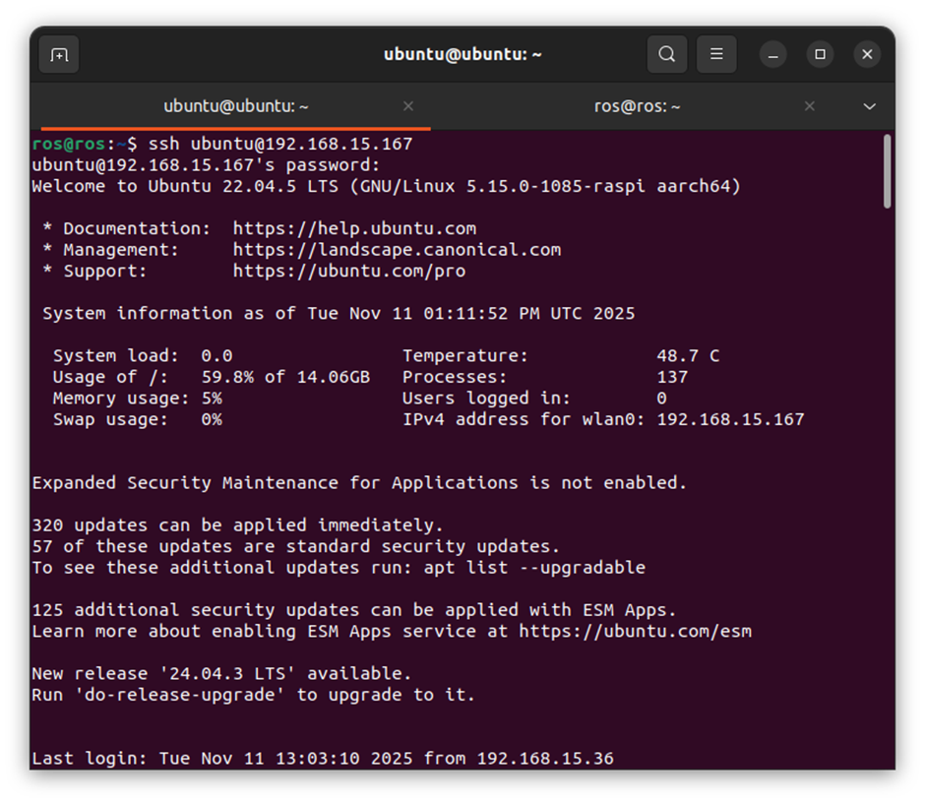

[2]: BRINGUP FOR BOT
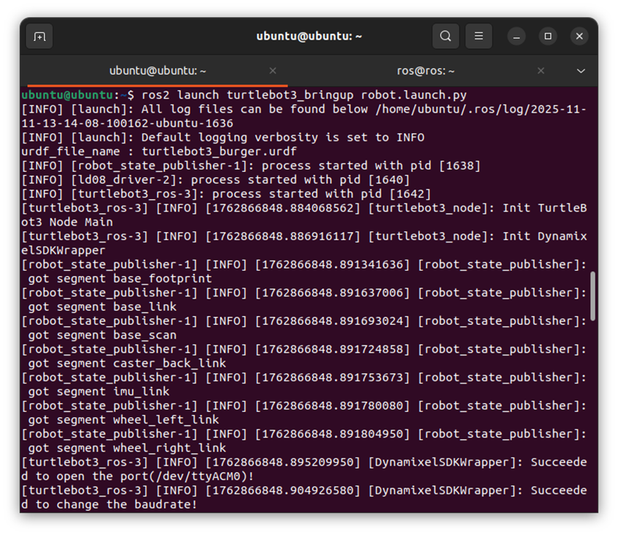
[3]: LAUNCH RVIZ
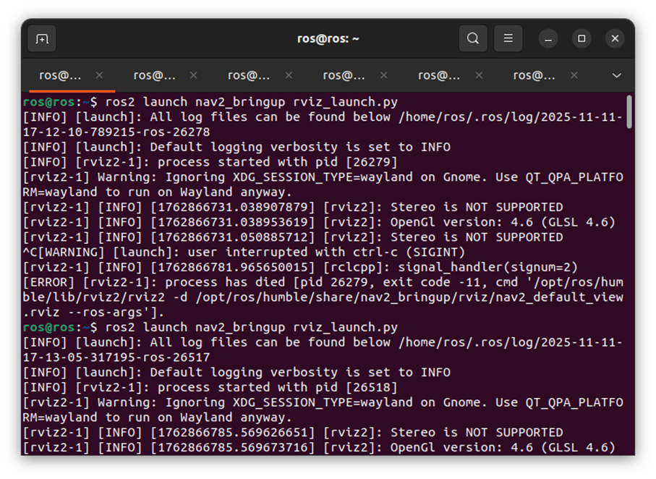
[4]: LAUNCH CARTOGRAPHER
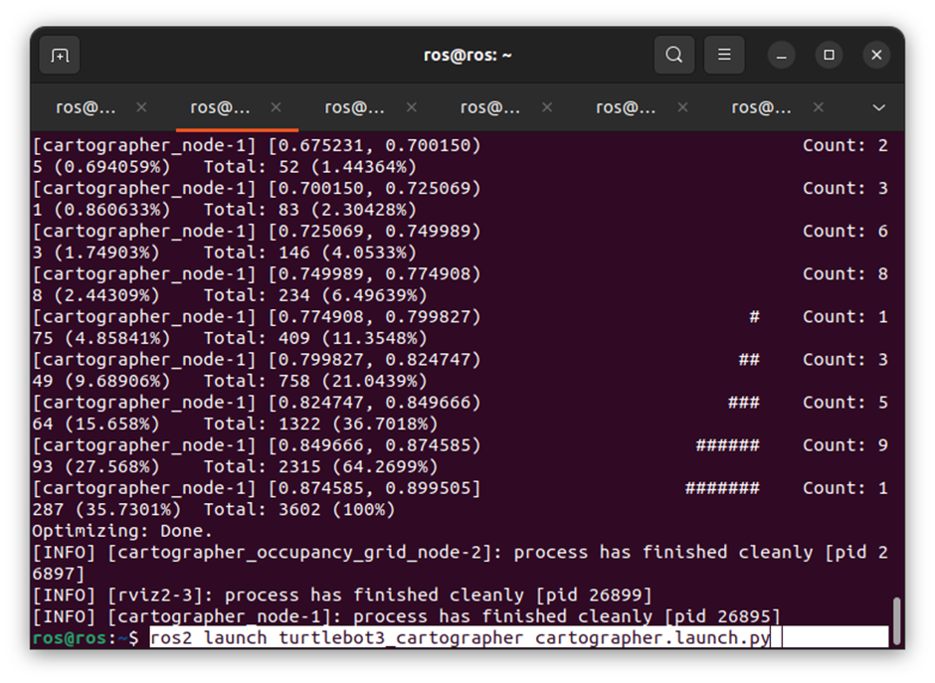
[5]: LAUNCH TELEOP
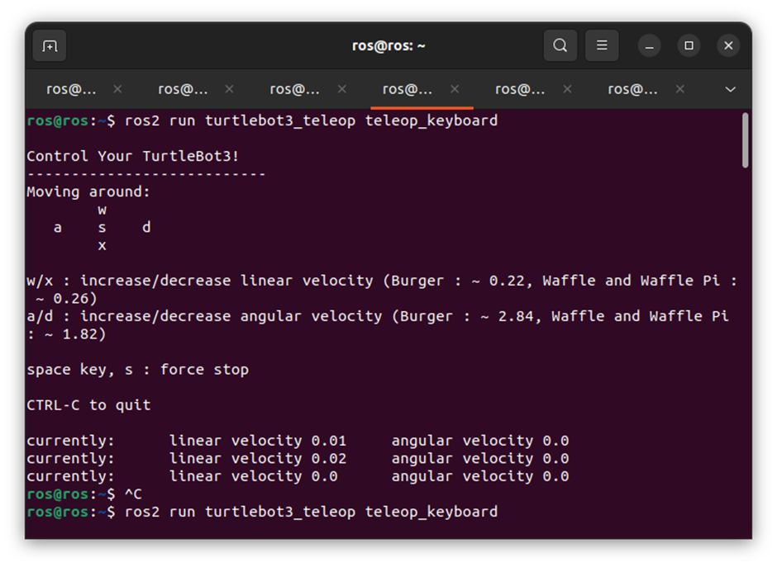
[6]: SAVE MAP
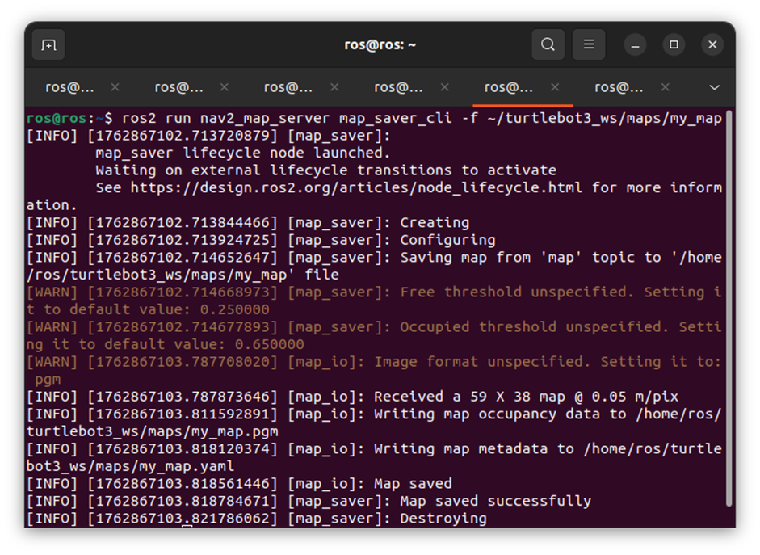

[7]: THE MAP

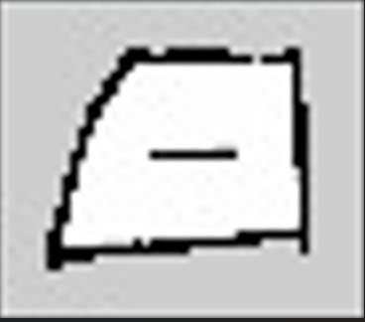

[8]: NAVIGATION
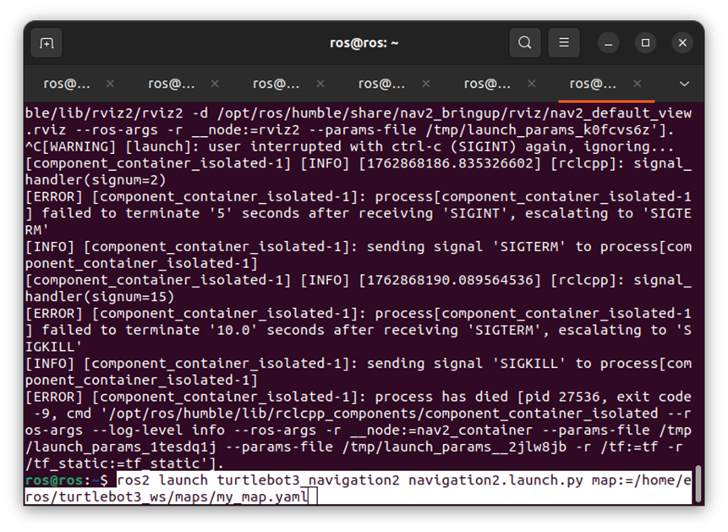

[9]: RVIZ (2D Pose Estimate and Nav2 Goal)
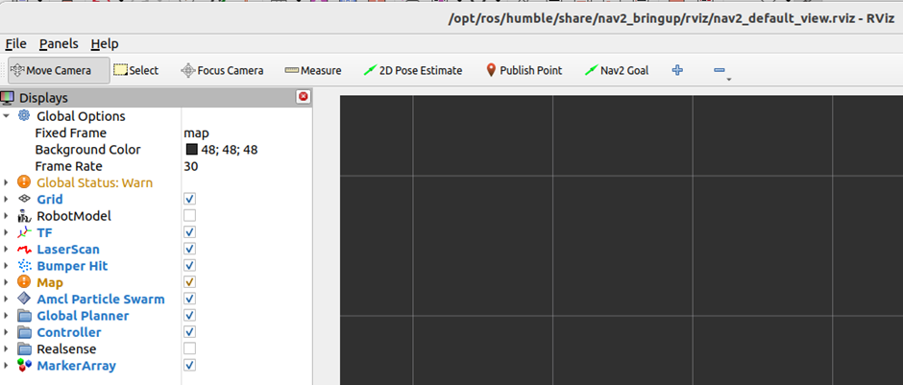

[10]: AMCL
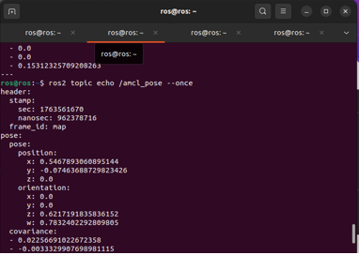

[11]: WAIT FOR 10 SECONDS
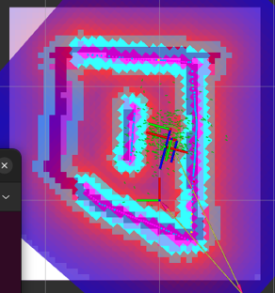

[12]: LAUNCH CAMERA
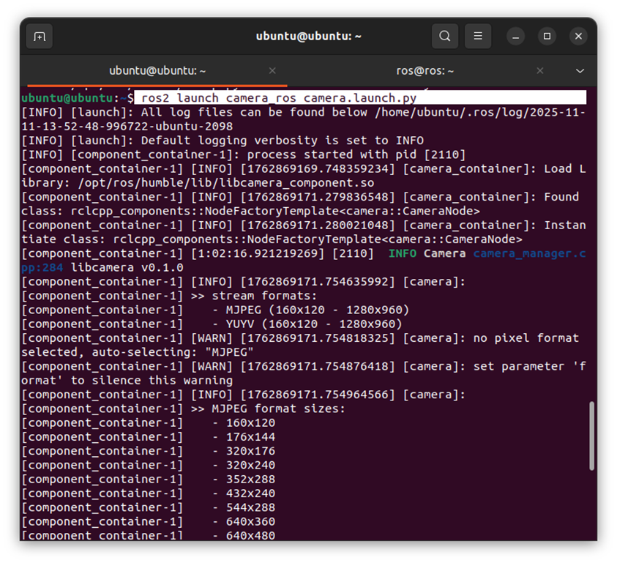

[13] : INSTALL CAMERA
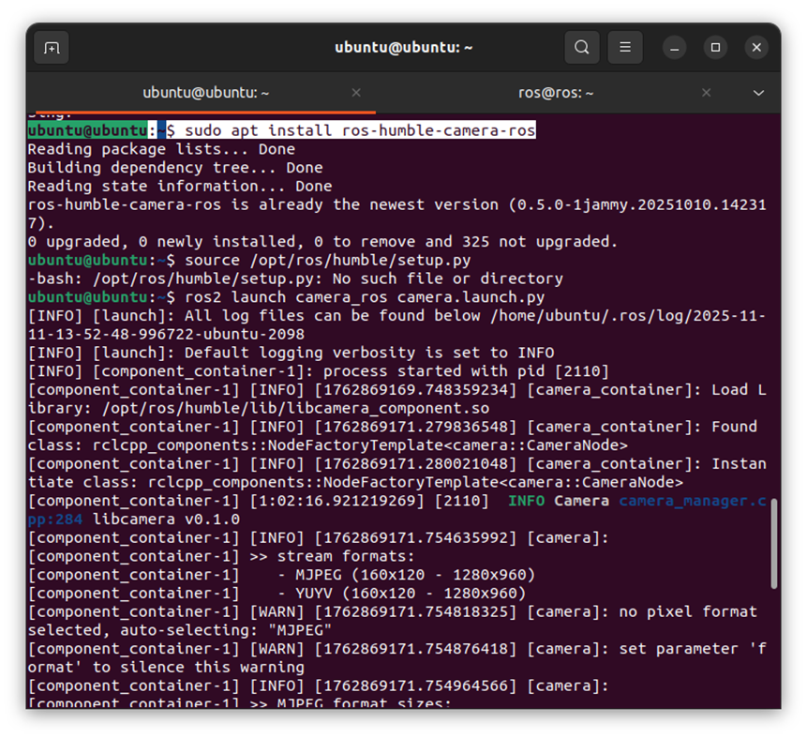

[14]:TRANSPORT PLUGINS
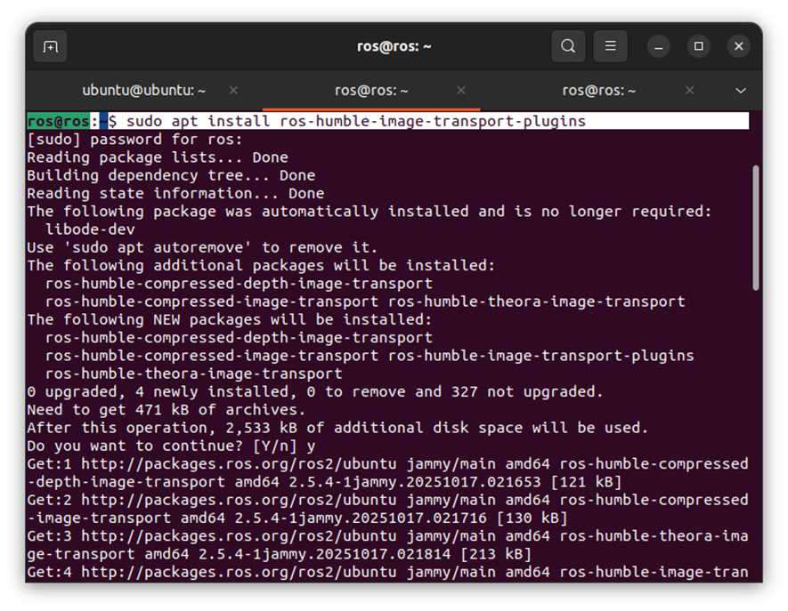

[15]: RQT
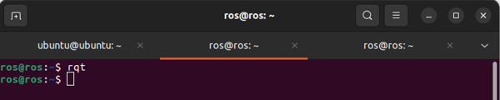

[16]: BLOCKS EXAMPLE
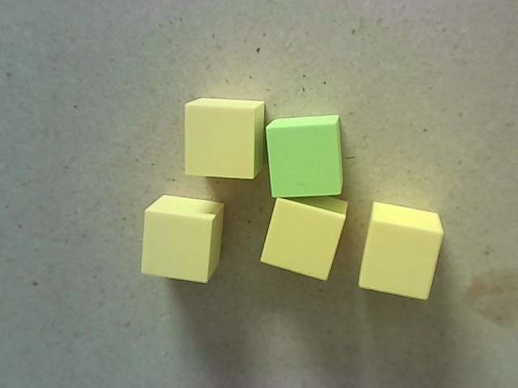

[17]: HSV COLOR RANGES SLIDER
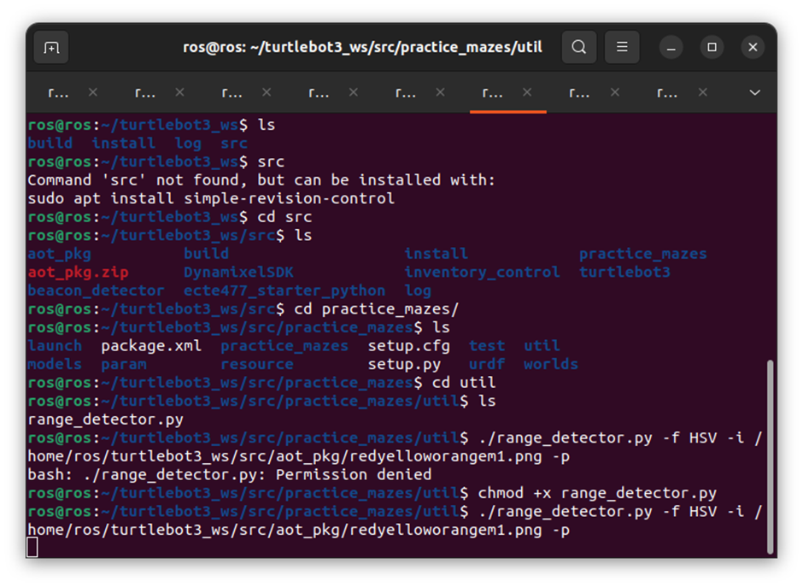

[18]: HSV EXAMPLE
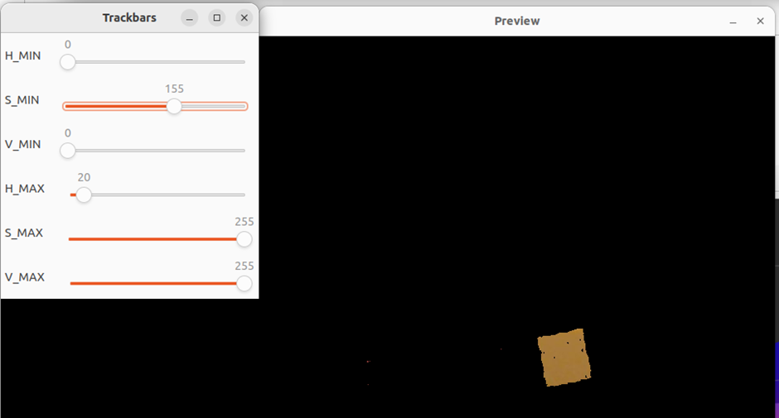

[19]: CREATE INVENTORY CONTROL PACKAGE
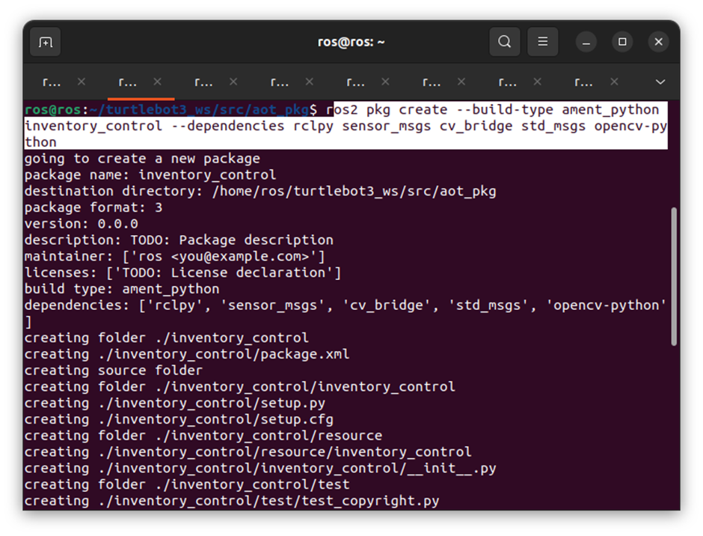

[20]:RUN INVENTORY VISION
